:DISPlay Commands

The :DISPlay commands can be used to set the waveform display mode, persistence time, waveform intensity, screen grid type and grid brightness.

Command List:
- :DISPlay:CLEar
- :DISPlay:DATA?
- :DISPlay:TYPE
- :DISPlay:GRADing:TIME
- :DISPlay:WBRightness
- :DISPlay:GRID
- :DISPlay:GBRightness

:DISPlay:CLEar
Syntax | :DISPlay:CLEar
Description | Clear all the waveforms on the screen.
Explanation | - If the oscilloscope is in the RUN state, waveform will still be displayed.  - This command is equivalent to pressing the CLEAR key at the front panel. Sending the :CLEar command can also clear all the waveforms on the screen.
Related command | :RUN

:DISPlay:DATA?
Syntax | :DISPlay:DATA?
Description | Read the bitmap data stream of the image currently displayed.
Explanation | The command is sent from the PC to the instrument through the VISA interface. The instrument responds to the command and directly returns the bitmap data stream of the image currently displayed to the buffer area of the PC.
Return format | Component | Size (length) | Example | Explanation
 | TMC  Blockheader | N^{[1]}+2 | #9001152054 | TMC Blockheader ::= #NXXXXXX is used to describe the length of the data stream. Wherein, # is the start denoter of the data stream; N is less than or equal to 9 and the N figures following it denote the length of the data stream in bytes. For example, #9001152054; wherein, N is 9 and 001152054 denotes that the data stream contains 1152054 bytes of effective data.
 | TMC  Blockheader | 800*480*3+5 4=1152054^{[2]} | BM… | Specific bitmap data.
Note[1]: N is the width of the data length in the TMC header. For example, the number “9” behind “#” in #9001152054.
Note[2]: The width is 800, the height is 480, the bit depth is 24 bit = 3 byte, 54 is the size
of the bitmap file header.
Example | - Make sure that the buffer is large enough to receive the data stream, otherwise the program might be abnormal when reading the data stream.  - The returned data stream contains the TMC data header which should be removed to make the data stream a standard bitmap data stream.  - When the data size is larger than 1 M and the communication speed of the interface is not fast enough, you need to set an appropriate timeout time.  - The terminator '\n'(0X0A) at the end of the data should be removed.  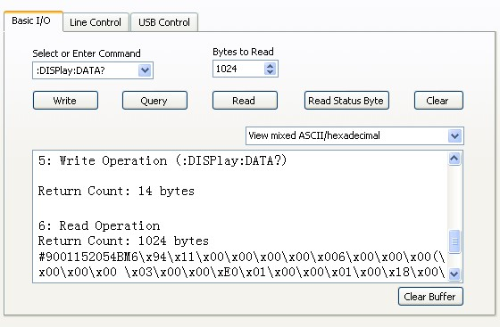

:DISPlay:TYPE
Syntax | :DISPlay:TYPE <type>  :DISPlay:TYPE?
Description | Set or query the display mode of the waveform on the screen.
Parameter | Name | Type | Range | Default
 | <type> | Discrete | {VECTors|DOTS} | VECTors
Explanation | - VECTors: the sample points are connected by lines. Normally, this mode can provide the most vivid waveform to view the steep edge of the waveform (such as square waveform).  - DOTS: display the sample points directly. You can directly view each sample point and use the cursor to measure the X and Y values of the sample point.
Return format | The query returns VECT or DOTS.
Example | :DISPlay:TYPE DOTS /*Select dots display mode*/  :DISPlay:TYPE? /*The query returns DOTS*/

:DISPlay:GRADing:TIME
Syntax | :DISPlay:GRADing:TIME <time>  :DISPlay:GRADing:TIME?
Description | Set or query the persistence time. The default unit is s.
Parameter | Name | Type | Range | Default
 | <time> | Discrete | {MIN|0.1|0.2|0.5|1|5|10|INFinite} | MIN
Explanation | - MIN: set the persistence time to its minimum to view the waveform changing in high refresh rate.  - Specific Values: set the persistence time to one of the values listed above to observe glitch that changes relatively slowly or glitch with low occurrence probability.  - INFinite: in this mode, the oscilloscope displays the newly acquired waveform without clearing the waveform formerly acquired. It can be used to measure noise and jitter as well as capture incidental events.
Return format | The query returns MIN, 0.1, 0.2, 0.5, 1, 5, 10 or INF.
Example | :DISPlay:GRADing:TIME 0.1 /*Set the persistence time to 0.1s*/  :DISPlay:GRADing:TIME? /*The query returns 0.1*/

:DISPlay:WBRightness
Syntax | :DISPlay:WBRightness <time>  :DISPlay:WBRightness?
Description | Set or query the waveform brightness.
Parameter | Name | Type | Range | Default
 | <time> | Integer | 0 to 100 | 60
Return format | The query returns an integer between 0 and 100.
Example | :DISPlay:WBRightness 50 /*Set the waveform brightness to 50%*/  :DISPlay:WBRightness? /*The query returns 50*/

:DISPlay:GRID
Syntax | :DISPlay:GRID <grid>  :DISPlay:GRID?
Description | Set or query the grid type of screen display.
Parameter | Name | Type | Range | Default
 | <grid> | Discrete | {FULL|HALF|NONE} | FULL
Explanation | - FULL: turn the background grid and coordinate on.  - HALF: turn the background grid off and coordinate on.  - NONE: turn the background grid and coordinate off.
Return format | The query returns FULL, HALF or NONE.
Example | :DISPlay:GRID NONE /*Turn the background grid and coordinate off*/ :DISPlay:GRID? /*The query returns NONE*/

:DISPlay:GBRightness
Syntax | :DISPlay:GBRightness <brightness>  :DISPlay:GBRightness?
Description | Set or query the brightness of the screen grid.
Parameter | Name | Type | Range | Default
 | <brightness> | Integer | 0 to 100 | 50
Return format | The query returns an integer between 0 and 100.
Example | :DISPlay:GBRightness 60 /*Set the brightness of the screen grid to 60%*/  :DISPlay:GBRightness? /*The query returns 60*/

